National Textile University, Faisalabad

Department of Computer Science
Name | Dawood Saif
Class | SE-6th (A)
Reg. No. | 23-NTU-CS-1145
Course | Mobile Application Development
Submitted To | Sir Rehan Sarwar
Submission Date | 16/03/2026
Lab Plan | 4

Phase 1: The Static Structure

Task 1: The Safe Scaffold o Create a StatelessWidget and return a Scaffold. o Wrap the body in a SafeArea to prevent the UI from hitting the status bar or notch.’

Task 2: The Header (Circular Avatar & Margin) o Use a Container with a margin (e.g., EdgeInsets.all(20.0)) to provide breathing room. o Place a CircleAvatar inside to represent the user's profile image.

Task 3: Layout Alignment o Use a Column to stack the Avatar and two Text widgets (Name and Title). o Set crossAxisAlignment to CrossAxisAlignment.center to align all elements to the middle.

Code;
import 'package:flutter/material.dart';

void main() {
runApp(const MyApp());
}

class MyApp extends StatelessWidget {
const MyApp({super.key});

@override
Widget build(BuildContext context) {
return const MaterialApp(
home: ProfilePage(),
);
}
}

class ProfilePage extends StatelessWidget {
const ProfilePage({super.key});

@override
Widget build(BuildContext context) {
return Scaffold(
appBar: AppBar(title: const Text('Profile')),
body: SafeArea(
child: Column(
crossAxisAlignment: CrossAxisAlignment.center,
children: [
Container(
margin: const EdgeInsets.all(20.0),
child: const CircleAvatar(
radius: 50,
backgroundImage: NetworkImage(
'https://robbreport.com/wp-content/uploads/2024/08/temerario01.jpg?w=800',
),
),
),
const Text(
'Dawood Saif Cheema',
style: TextStyle(fontSize: 22, fontWeight: FontWeight.bold),
),
const Text(
'Devops Engineer ',
style: TextStyle(fontSize: 16, color: Colors.grey),
),
],
),
),
);
}
}

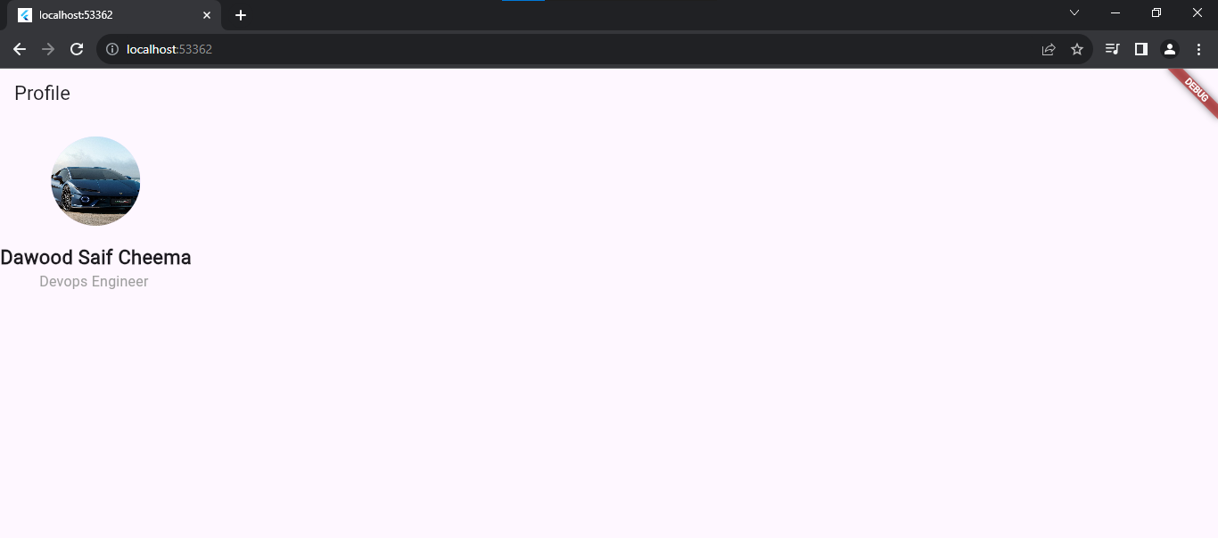

Phase 2: Proportional & Flexible Layouts

Task 4: The Body Content (Expanded & Proportions) o Add a Row below the header inside the main Column. o Insert two Container widgets inside this Row. o Wrap both in Expanded widgets. Set the first container's flex to 2 and the second to 1 to create a 2:1 width ratio.

Task 5: Spacing with SizedBox o Instead of using heavy padding, use a SizedBox with a fixed height or width to create gaps between widgets.

Code;
import 'package:flutter/material.dart';

void main() {
runApp(const MyApp());
}

class MyApp extends StatelessWidget {
const MyApp({super.key});

@override
Widget build(BuildContext context) {
return const MaterialApp(
home: ProfilePage(),
);
}
}

class ProfilePage extends StatelessWidget {
const ProfilePage({super.key});

@override
Widget build(BuildContext context) {
return Scaffold(
appBar: AppBar(title: const Text('Profile')),
body: SafeArea(
child: Column(
crossAxisAlignment: CrossAxisAlignment.center,
children: [
Container(
margin: const EdgeInsets.all(20.0),
child: const CircleAvatar(
radius: 50,
backgroundImage: NetworkImage(
'https://robbreport.com/wp-content/uploads/2024/08/temerario01.jpg?w=800',
),
),
),
const Text(
'Dawood Saif Cheema',
style: TextStyle(fontSize: 22, fontWeight: FontWeight.bold),
),
const Text(
'Devops Engineer',
style: TextStyle(fontSize: 16, color: Colors.grey),
),
const SizedBox(height: 20),
Row(
children: [
Expanded(
flex: 2,
child: Container(
height: 100,
color: Colors.blue[100],
child: const Center(child: Text('Bio / About (flex: 2)')),
),
),
const SizedBox(width: 10),
Expanded(
flex: 1,
child: Container(
height: 100,
color: Colors.green[100],
child: const Center(child: Text('Stats (flex: 1)')),
),
),
],
),
],
),
),
);
}
}

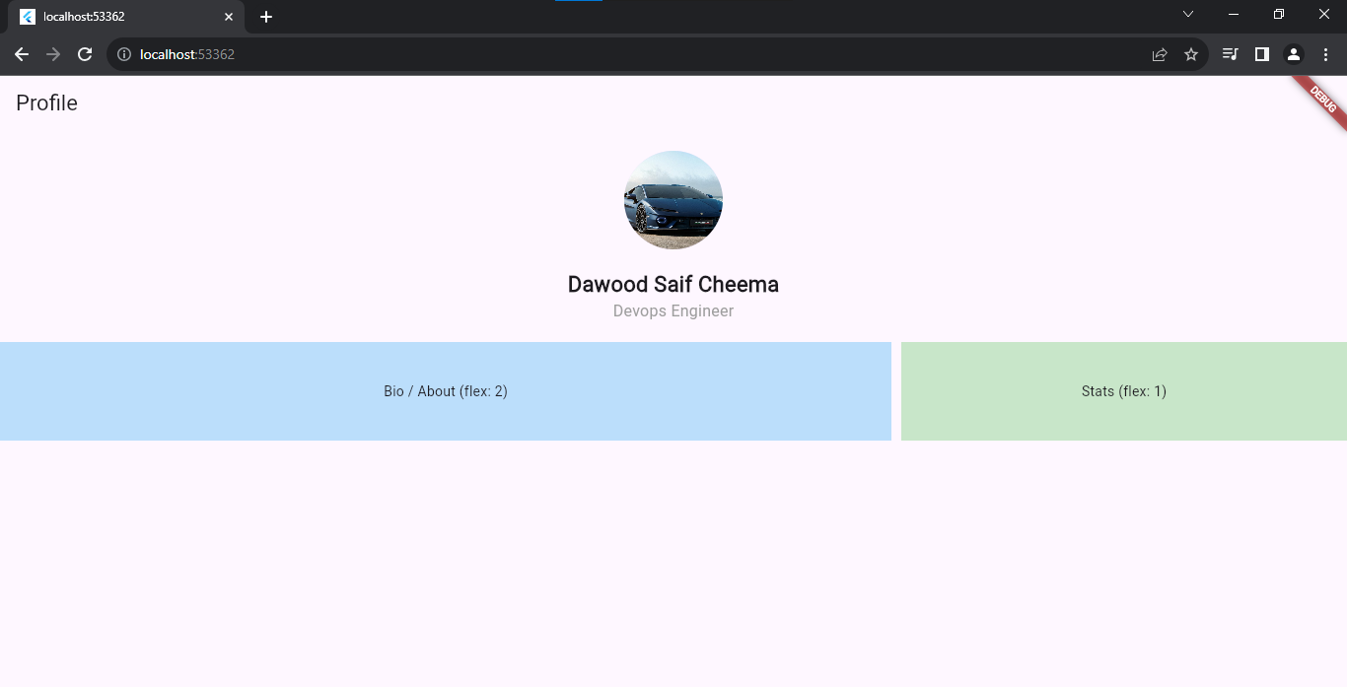
Phase 3: Interactivity & State Management
Task 6: Refactoring to StatefulWidget o Convert the widget from Stateless to Stateful using the stf shortcut. o Define a boolean variable isFollowed and an integer score in the _State class.
Task 7: Material Buttons & setState o Add an ElevatedButton for "Follow" and an IconButton for "Like". o In the onPressed callback, use setState() to toggle the isFollowed status or increment the score.
Task 8: Material Card Implementation o Wrap the statistics (score) in a Card widget to give it a shadowed, elevated look. o Use a ListTile inside the card for a clean "Icon + Title + Subtitle" arrangement.

Code:
import 'package:flutter/material.dart';

void main() {
runApp(const MyApp());
}

class MyApp extends StatelessWidget {
const MyApp({super.key});

@override
Widget build(BuildContext context) {
return const MaterialApp(
home: ProfilePage(),
);
}
}

class ProfilePage extends StatefulWidget {
const ProfilePage({super.key});

@override
State<ProfilePage> createState() => _ProfilePageState();
}

class _ProfilePageState extends State<ProfilePage> {
bool isFollowed = false;
int score = 0;

@override
Widget build(BuildContext context) {
return Scaffold(
appBar: AppBar(title: const Text('Profile')),
body: SafeArea(
child: Column(
crossAxisAlignment: CrossAxisAlignment.center,
children: [
// Header
Container(
margin: const EdgeInsets.all(20.0),
child: const CircleAvatar(
radius: 50,
backgroundImage: NetworkImage(
'https://robbreport.com/wp-content/uploads/2024/08/temerario01.jpg?w=800',
),
),
),
const Text(
'Dawood Saif',
style: TextStyle(fontSize: 22, fontWeight: FontWeight.bold),
),
const Text(
'Devops Engineer',
style: TextStyle(fontSize: 16, color: Colors.grey),
),

const SizedBox(height: 20),

// Proportional Row
Row(
children: [
Expanded(
flex: 2,
child: Container(
height: 100,
color: Colors.blue[100],
child: const Center(child: Text('Bio / About (flex: 2)')),
),
),
const SizedBox(width: 10),
Expanded(
flex: 1,
child: Container(
height: 100,
color: Colors.green[100],
child: const Center(child: Text('Stats (flex: 1)')),
),
),
],
),

const SizedBox(height: 20),

// Task 7: Follow Button + Like IconButton
Row(
mainAxisAlignment: MainAxisAlignment.center,
children: [
ElevatedButton(
onPressed: () {
setState(() {
isFollowed = !isFollowed;
});
},
child: Text(isFollowed ? 'Following ✓' : 'Follow'),
),
const SizedBox(width: 16),
IconButton(
icon: Icon(
Icons.thumb_up,
color: score > 0 ? Colors.blue : Colors.grey,
),
onPressed: () {
setState(() {
score++;
});
},
),
],
),

const SizedBox(height: 16),

// Task 8: Card with ListTile
Card(
elevation: 4,
margin: const EdgeInsets.symmetric(horizontal: 20),
child: ListTile(
leading: const Icon(Icons.star, color: Colors.amber),
title: const Text('Score'),
subtitle: Text('$score likes received'),
),
),
],
),
),
);
}
}

